Token Embedding
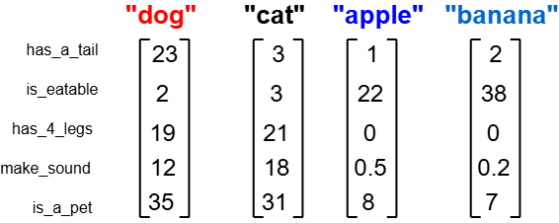
How are these vectors created?
We can train a neural network to turn words into vector embeddings. By looking at sentences in a document, the model learns which words often appear together and which have similar meanings.
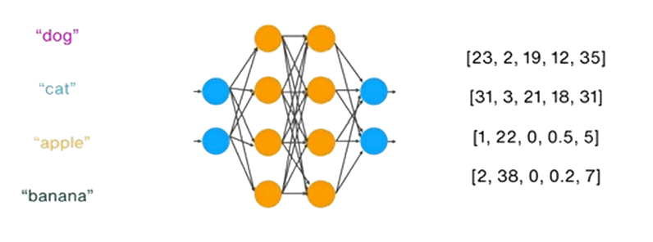
But this isn’t easy. For example, a model like GPT-2 has a vocabulary of about 50,000 words. That means it needs to learn a vector for each word and understand how they relate to one another. Doing this requires a lot of computation and data

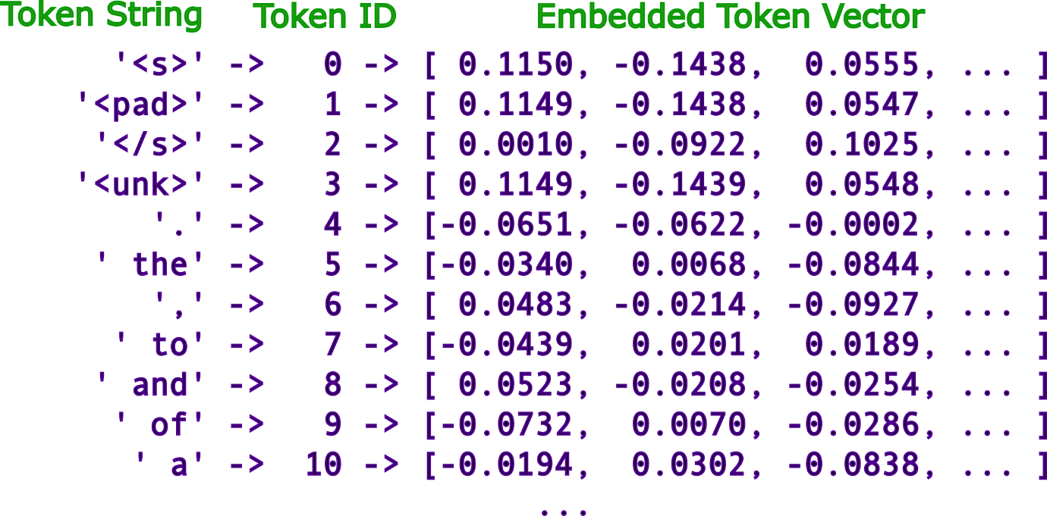

Embedding Model Comparison:
Model | Type | Embedding size  (dim) | Vocabulary size | Notes
Word2Vec | Static | 300 | ~3M (Google News) | One vector per word
ELMo | Context-aware (LSTM) | 256–1024 | No fixed vocab  (char-based) | Infinite word handling
DeepSeek | Transformer | ~4K–8K | ~100K–200K | Efficient scaling
GPT-2 (small) | Transformer | 768 | 50,257 | Subword BPE
GPT-3 (Davinci) | Transformer | 12,288 | ~100K | Much larger latent space
Modern LLMs (e.g. GPT-4 class) | Transformer | 3K–12K+ | 100K–200K+ | Larger vocab trend

How are these vectors created?
Step1: Start with a tiny dataset:

Imagine we have this small corpus:
From this, our vocabulary is:
["the", "cat", "dog", "sits", "on", "mat", "log"]

"the cat sits on the mat"
"the dog sits on the log"

Step2: Create training pairs
(context learning):
If we choose a window size of 1, training pairs look like:
- (“the” → “cat”), (“the” → “sits”),
- ("cat" → "the"), ("cat" → "sits"), ("cat" → "on")
- (“sits” → “the”), ("sits" → "cat"), ("sits" → "on")
- (on, cat), (on, sits), (on, the), (on, mat),
- (the, sits), (the, on), (the, mat),
- (mat, on), (mat, the)
So the model learns: words appearing in similar contexts should have similar vectors.

One simple method is Word2Vec (Skip-gram).
The idea: given a word, predict its
surrounding words.

"the cat sits on the mat"

Step 4: Neural network structure:

A very simple network:
Input (one-hot) → Hidden layer → Output layer
- Input size = vocabulary size (7)
- Hidden layer = embedding size (say 3)
- Output = probability of context words

What happens during training
When the model processes:
Case 1: ("cat" → "sits")
- It adjusts weights so cat’s vector helps predict "sits"
Case 2: ("dog" → "sits")
- It adjusts weights so dog’s vector helps predict "sits"
Since both:
- need to predict the same outputs
- receive similar gradient updates

Step3: Convert words to numbers:
We encode each word as a one-hot vector:
Example (7 words total):
- “the” → [1,0,0,0,0,0,0]
- "cat" → [0,1,0,0,0,0,0]
- "dog" → [0,0,1,0,0,0,0]
These are sparse and not meaningful yet.

Step 5: Training process
For each pair like ("cat" → "sits"):
- Input: one-hot("cat")
- Predict: probability distribution over all words
- Compare with actual ("sits")
- Compute loss (cross-entropy)
- Update weights using backpropagation
Repeat this thousands/millions of times.

Step 6: Final result (embeddings)
cat ≈ [0.2, 0.8, 0.1]
dog ≈ [0.25, 0.75, 0.15]
mat = [0.9, 0.1, 0.2]
log = [0.85, 0.15, 0.25]

# Step 1: Toy dataset  sentences = [  ["the", "cat", "sits", "on", "the", "mat"],  ["the", "dog", "sits", "on", "the", "log"]  ]  Step 2: Build vocabulary  import numpy as np  words = list(set(w for s in sentences for w in s))  word_to_idx = {w:i for i,w in enumerate(words)}  idx_to_word = {i:w for w,i in word_to_idx.items()}  vocab_size = len(words)  embedding_dim = 2 | Step 3: Generate training pairs (window=1)  pairs = []  window = 1  for sent in sentences:  for i, word in enumerate(sent):  for j in range(max(0, i-window), min(len(sent), i+window+1)):  if i != j:  pairs.append((word, sent[j]))  # Step 4: Initialize weights  W1 = np.random.randn(vocab_size, embedding_dim) # embeddings  W2 = np.random.randn(embedding_dim, vocab_size) # output
# Step 5: Helper functions  def softmax(x):  e_x = np.exp(x - np.max(x))  return e_x / e_x.sum()  def one_hot(idx, size):  vec = np.zeros(size)  vec[idx] = 1  return vec  # Step 6: Helper functions  lr = 0.05  for epoch in range(5000):  loss = 0  for target, context in pairs:  x = one_hot(word_to_idx[target], vocab_size)  y_true = one_hot(word_to_idx[context], vocab_size)  # Forward pass  h = np.dot(x, W1) # embedding  u = np.dot(h, W2) # scores  y_pred = softmax(u)  # Loss (cross-entropy)  loss -= np.log(y_pred[np.argmax(y_true)] + 1e-9)  # Backprop  error = y_pred - y_true  dW2 = np.outer(h, error)  dW1 = np.outer(x, np.dot(W2, error))  # Update  W1 -= lr * dW1  W2 -= lr * dW2  if epoch % 1000 == 0:  print(f"Epoch {epoch}, Loss: {loss:.4f}")  # Step 7: Inspect embeddings  for word in words:  print(word, W1[word_to_idx[word]]) | PyTorch Implementation (Skip-gram)  Step 1: Dataset : Same as Step1- Toy dataset  Step 2: Training pairs: Same as Step3 - Generate training pairs  Step 3: Model  # nn.Embedding is just a lookup table (no explicit one-hot needed)  class SkipGram(nn.Module):  def __init__(self, vocab_size, embedding_dim):  super().__init__()  self.embeddings = nn.Embedding(vocab_size, embedding_dim)  self.output = nn.Linear(embedding_dim, vocab_size)  def forward(self, x):  x = self.embeddings(x) # this replaces one-hot + matrix multiply  x = self.output(x)  return x  Step 4: Training  for epoch in range(1000):  total_loss = 0  for target, context in pairs:  target = torch.tensor([target])  context = torch.tensor([context])  output = model(target)  loss = loss_fn(output, context)  optimizer.zero_grad()  loss.backward()  optimizer.step()  total_loss += loss.item()  if epoch % 200 == 0:  print(f"Epoch {epoch}, Loss: {total_loss:.4f}")  Step 5: Training  embeddings = model.embeddings.weight.data  for word, idx in word_to_idx.items():  print(word, embeddings[idx])

Contextual Embedding in Transformer
Input sentence:
What’s different in transformers?
Word2Vec:
- Static embeddings (same vector always)
Transformers:
- Contextual embeddings
Example:
"bank" in:
- "river bank"
- "bank account"
Different vectors!
"the cat sits on the mat"

Step 1: Tokenization
["the", "cat", "sits"] → [5, 12, 33]

Step 2: Embedding lookup
[5, 12, 33] →
[
[0.1, 0.8, ...], # "the"
[0.2, 0.7, ...], # "cat"
[0.3, 0.6, ...] # "sits"
]
👉 Same idea as your model.
Token IDs
↓
Embedding Layer ← (what you implemented)
↓
+ Positional Encoding
↓
Transformer Blocks (attention)
↓
Output probabilities

How transformers achieve Self-attention?
Instead of:
word → fixed vector
They do:
word → embedding → attention → context-aware vector

Why positional encoding? (why order matter?)

1. The core problem:
Attention has no sense of order
3. Why self-attention alone is not enough
If we remove positional encoding, the model sees a bag of words:
I, deposited, money, in, the, bank

Self-attention computes relationships like:
“Which words are relevant to each other?”
But without positional encoding, it does NOT know:
“What is the order of those words?”
So “money → bank” and “bank → money” would look identical in a bag-of-words sense.

1. “I deposited money in the bank”
2. “bank the in money deposited I”
Even though both contain the same words, But
meaning depends heavily on order

2. Why position matters
(your example: “bank”)
Consider the sentence:
“I deposited money in the bank”
Here, “bank” = financial institution
Note: Why not just use numbers like 1, 2, 3, 4…?
We could assign:
- “I” → 1 , “deposited” → 2 , “money” → 3
This causes problems:
- The model might think position 10 is “10× bigger” than position 1 (which is not meaningful in language)
- It doesn’t generalize well to longer sequences than it saw during training
So instead, Transformers use a smooth mathematical pattern: sine and cosine waves.
position | sin(pos) | cos(pos)
1 | 0.84 | 0.54
2 | 0.91 | -0.42
3 | 0.14 | -0.99

“bank at position 6” ≠ bank at position 2”
even if the word is identical
But compare:
“I sat on the river bank”
Here, “bank” = river edge.

The word “bank” is ambiguous. The meaning
is resolved by context and position:
Even dimensions:
$$PE(pos,2i)=sin⁡\left(\frac{pos}{{10000}^{2i/d}}\right)$$Odd dimensions: $$PE(pos,2i+1)=cos⁡\left(\frac{pos}{{10000}^{2i/d}}\right)$$
- pos = word position in sentence
- d = embedding dimension (e.g., 512 or 768)
- i = dimension index

Why Self-attention? (Why Attention matter?)
Embeddings alone don’t understand order.
Step 3: Self-attention idea
We compute:
- Query (Q): what I’m looking for
- Key (K): what I represent
- Value (V): what I contain
For simplicity, assume:
Q = K = V = embeddings

Case A: “bank” in financial context
Sentence:
I deposited money in the bank

We compute similarity of bank with other words.
Dot products (simplified):
bank · money = HIGH (0.5·0.9 + ...)
bank · deposited = HIGH
bank · river = LOW
bank · sat = LOW

Softmax result (attention weights):
money → 0.45
deposited → 0.35
others → 0.20

New representation of “bank”:
bank_finance =
0.45·money + 0.35·deposited + 0.20·others

Case B: “bank” in river context
Sentence:
I sat on the river bank

Now attention changes:
bank · river = HIGH
bank · sat = MEDIUM
bank · money = LOW

Softmax result (attention weights):
river → 0.50
sat → 0.30
others → 0.20

New representation:
bank_river =
0.50·river + 0.30·sat + 0.20·others

“I deposited money in the bank”
“I sat on the river bank”
The word bank has two meanings:
- 💰 financial institution
- 🌊 river edge

Step1: Token embeddings
Let’s simplify embeddings to 3D vectors:
bank = [0.5, 0.5, 0.5]
money = [0.9, 0.1, 0.2]
river = [0.2, 0.9, 0.3]
deposited = [0.8, 0.2, 0.4]
sat = [0.3, 0.7, 0.6]

Step2: Add positional encoding
Sentence 1:
I deposited money in the bank
Sentence 2:
I sat on the river bank

Even after positional encoding, bank is still ambiguous.
So we need attention.

------------------------------------------------------

Full attention matrix view
For every word, transformer builds a grid like this:
 | I | deposited | money | river | bank
I | 0 | 0.1 | 0.1 | 0.0 | 0.1
deposited | 0 | 0.1 | 0.3 | 0.0 | 0.2
money | 0 | 0.2 | 0.2 | 0.0 | 0.1
river | 0 | 0.0 | 0.0 | 0.2 | 0.4
bank | 0 | 0.3 | 0.4 | 0.5 | 0.1
This is usually visualized as a heatmap where:
- bright = strong attention
- dark = weak attention

Multi-head Attention
- grammar (who did what)
- Semantic meaning (financial vs river bank)
- relationships (verb-object links)

Concatenation of Multiple Attention Heads
┌──────────────┐
│ Head 1 │ → meaning (money)
├──────────────┤
BANK ──────────▶│ Head 2 │ → grammar (verb/object)
├──────────────┤
│ Head 3 │ → context (location)
└──────────────┘
↓
Concatenate + Linear layer
↓
FINAL CONTEXTUAL BANK VECTOR

Head 1 → [0.8, 0.1] (meaning)
Head 2 → [0.3, 0.9] (grammar)
Head 3 → [0.6, 0.4] (context)
We combine them:
BANK_final = concat(H1, H2, H3)

Full transformer forward pass walk through
We’ll use a simple sentence:
“I deposited money in the bank”

And we’ll pretend the model is trying to predict the next word after “bank”.

OVERVIEW:
Tokens → Embeddings (meaning) → Positional Encoding (order) → Multi-Head Self-Attention (relationships)
→ Feed Forward Network (feature refinement)
→ Final Linear Layer (map to vocabulary)
→ Softmax (probabilities) → Prediction / NEXT WORD

STEP 1: Tokenization  We convert text into token IDs: | STEP 2: Token Embeddings  Each token becomes a vector (say 4D for simplicity):
"I deposited money in the bank"  → [I, deposited, money, in, the, bank]  → [10, 532, 98, 44, 21, 77] | I → [0.2, 0.1, 0.7, 0.0]  deposited → [0.6, 0.2, 0.1, 0.9]  money → [0.9, 0.1, 0.3, 0.4]  in → [0.3, 0.8, 0.2, 0.1]  the → [0.5, 0.4, 0.6, 0.2]  bank → [0.7, 0.3, 0.8, 0.5]
Now we have a matrix: X = (6 tokens × 4 dims)

STEP 3: Positional Encoding (adds order  We add position vectors: | Example:
P0 = [0.0, 0.1, 0.0, 0.1]  P1 = [0.1, 0.0, 0.1, 0.0]  P2 = ...  Final input: X' = embedding + position | bank = [0.7, 0.3, 0.8, 0.5]  P5 = [0.1, 0.0, 0.1, 0.0]  → bank' = [0.8, 0.3, 0.9, 0.5]

STEP 4: Self-Attention  We compute for each token:  Q (Query), K (Key), V (Value)  Q = XWq  K = XWk  V = XWv | Focus on ONE token: “bank”  We compute how “bank” attends to all tokens:  Step 4.1: similarity scores  bank · I = 0.2  bank · money = 0.9 ← strong  bank · deposited = 0.85 ← strong  bank · in = 0.3  bank · the = 0.4  bank · bank = 0.6 | Step 4.2: softmax  (attention weights)  I → 0.05  deposited→ 0.30  money → 0.35  in → 0.05  the → 0.05  bank → 0.20

Step 4.3: weighted sum (new representation)
bank_context = 0.05·I + 0.30·deposited + 0.35·money + 0.20·bank + ...
👉 Now “bank” becomes financial-context-aware

STEP 5: Multi-head attention (parallel views)  concat(head1, head2, head3) → linear transform  STEP 7: Final Linear Layer (vocabulary projection)  We now predict next word:  logits = hidden_state(bank) · W_vocab | STEP 6: Feed Forward Network (MLP per token)  Each token independently passes through:  FFN(x) = W2(ReLU(W1x))  STEP 8: Softmax  Convert logits into probabilities:  P("loan") = 0.30  P("account")= 0.25  P("river") = 0.01
Model outputs: "I deposited money in the bank → loan"

